C:\Program Files (x86)\Microsoft Office\MEDIA\CAGCAT10\j0293240.wmfMemphis Primary Materials

Volume 1, Number 1 January 2016

**Memphis Primary Materials: An Introduction**

Memphis Primary Materials provides advanced recycling services to businesses in the Memphis, Tennessee, area and throughout Tennessee. In addition to collecting common recyclable materials like batteries, paper, and toner cartridges, we collect and recycle computers, monitors, copiers and fax machines, wood pallets, and compostable materials. Our company’s name comes from the process of capturing the “primary materials” of used items for reuse. We ensure that our clients comply with all state and local regulations regarding waste and equipment disposal. Our staff also provides training to clients on the process and benefits of recycling.

We strive to grow our business by advancing the ideas of reduce, reuse, and recycle among the business community.

**Memphis Primary Materials**

**5360 Airways Blvd., Suite 10A**

**Memphis, TN 38114**

**(901) 555-0862**

**Memphismaterials.net**

**CEO: Harold Boyd III**

**President: Barbara Collins**

**CFO: Joe Hedgepeth**

**Chief Environmental Officer: Denisha Geater**

**Make Recycling  
 Easy for Everyone!**

An easy way to help your staff and customers recycle is to place recycling bins around your office, customer areas, anywhere people pass by or congregate. One office collected over 1,000 batteries for recycling in a single month—small batteries used in electronic equipment that might otherwise have ended up in landfills. Employees at the company even said they had collected batteries from home and brought them to the office for recycling.

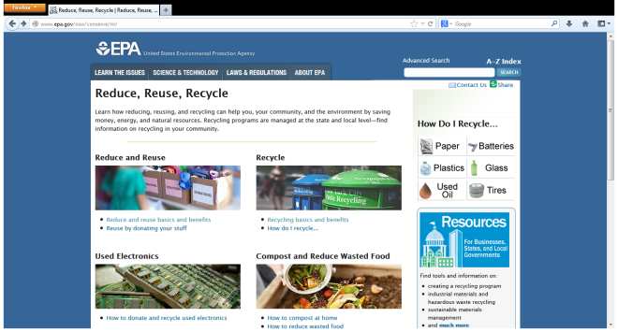You can make the process easier by placing various types of recycling bins around your workplace. Place paper recycle bins near copiers and printers where they are easily accessible. Place can and bottle bins in break rooms, near all trash cans, and near vending machines. Place battery bins around offices. For more very good ideas, visit the EPA Web site at www.epa.gov.